Using the ifood_df dataset
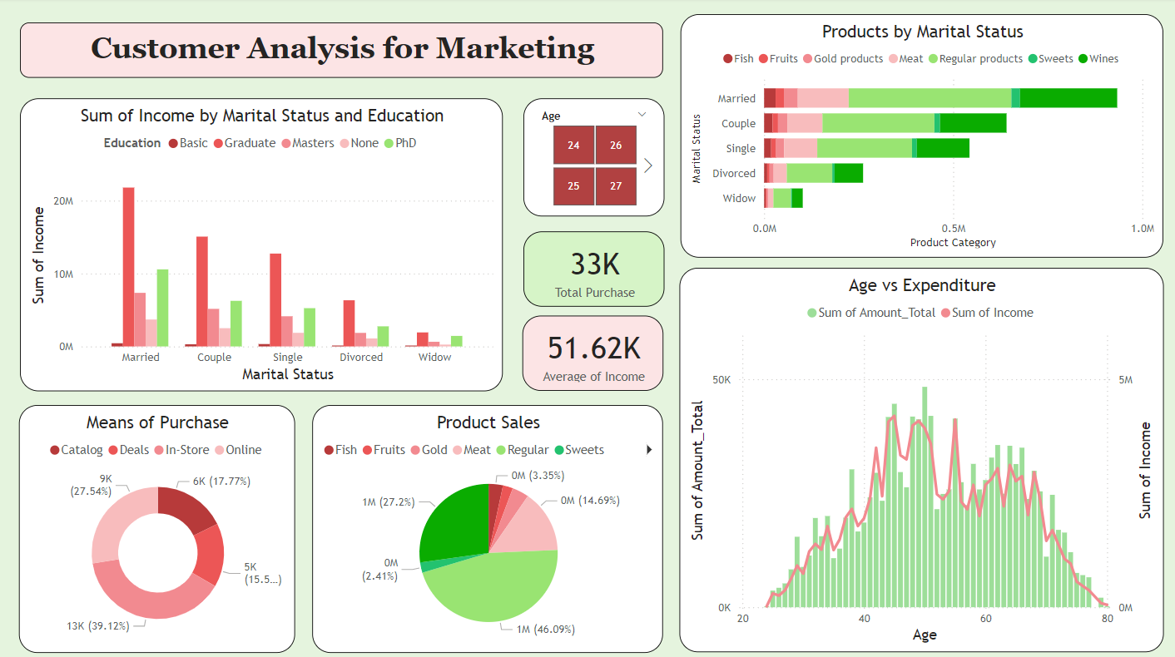
- Create a dashboard similar to the given image

- In second sheet create visualizations to answer following questions
No. | Analysis Question | VisualSuggestion | Key Fields to Use
1 | What is the overall customer lifetime value and engagement? | KPI Cards | SUM(MntTotal),COUNT(Customer_ID), AVERAGE(Recency), AVERAGE(Income)
2 | How is total spending distributed across product categories? | Donut Chart | MntWines, MntMeatProducts, MntFishProducts, MntSweetProducts, MntFruits
3 | How does total spending (MntTotal) vary by customer age? | Line or Area Chart | Age (on X-axis), SUM(MntTotal) (on Y-axis)
4 | Which demographics (Marital Status and Education) generate the highest average total spending? | Matrix Table | Marital Status (Rows), Education (Columns), AVERAGE(MntTotal) (Values)
5 | How does the presence of children (Kidhome and Teenhome) impact total spending? | Clustered Bar Chart | Kidhome and Teenhome (combined or separate bars), AVERAGE(MntTotal)
6 | What are the preferred purchase channels for customers? | Bar Chart | NumStorePurchases, NumWebPurchases, NumCatalogPurchases
7 | What is the current distribution of customers based on their last purchase date (Recency)? | Histogram / Column Chart | Recency (binned on X-axis), COUNT(Customer_ID) (on Y-axis)
8 | How successful were our marketing campaigns? | Waterfall Chart | AcceptedCmpOverall (Total Success), AcceptedCmp1 to AcceptedCmp5 (Breakdown by campaign)
9 | Is there a relationship between income and the number of deals customers accept? | Scatter Plot | Income (X-axis), NumDealsPurchases (Y-axis)
10 | What percentage of customers who complained (Complain=1) responded to the last campaign (Response=1)? | Card / Gauge Visual | Count of customers where Complain=1 and Response=1 divided by Count where Complain=1.

